June 09, 2010 Via email: lena.kahre@husqvarna.se

Husqvarna AB (Huskvarna)
SE-561 82, Huskvarna, Sweden.

Attention: Lena Kahre

Re: Vietnam – Recordal of Owner’s Address Change of Trademark Registration
Your Ref.: TM1039WO01
Our Ref.: H1323-8HNT
Country: Vietnam
Registration No.: 70356
Owner’s Name: Husqvarna Aktiebolag
Int’l Classes: 07, 08

Dear Lena Kahre,
We are pleased to inform you that the National Office of Intellectual Property (NOIP) has issued a decision on recordal of the change of the address of the owner of the aforementioned Trademark Registration, the particulars of which are indicated below:

Decision No.: 27133/QD-SHTT
Decision Date: December 28, 2009
Thes Decisions will be recorded into the National Registry and published in the Gazette of Industrial Property within two (02) months from the signing date.
Please note that a request for renewal of this Trademark Registration must be filed within six (06) months prior to the next Expiry Date, i. e. September 14, 2014. A late request for the renewal is acceptable within six (06) months following the Expiry Date, provided that a surcharge amounting to 10% of the renewal fee is paid for each month of late filing.
Please find attached a copy of the aforementioned Trademark Registration Certificate wherein the particulars of the owner’s address change have been recorded and English translations thereof. The original Registration Certificate along with the original copy of this letter will be sent to you by courier when the payment of our final Debit Note for this matter is received.
We thank you for the opportunity to serve you in this matter and look forward to a continuous and fruitful cooperation with you and your firm. Please do not hesitate to contact us should you need any further assistance.

Very truly yours,
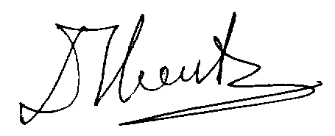
Duong Trung Hieu (Mr.), Senior Trademark Attorney
cc: Nguyen Thi Phi Nga (Mrs.), Department Head – Intellectual Property

